Workouts for 5-6, 5-7, and 5-8
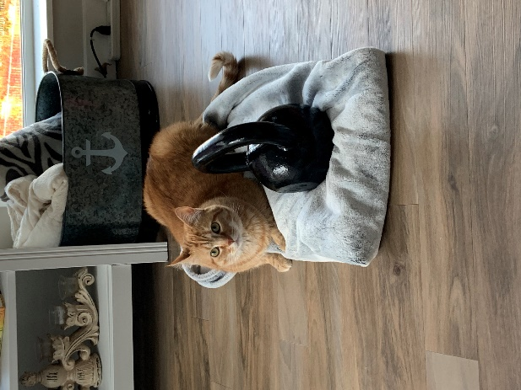
Wednesday: Strength Training
Watch Backpack Day
https://www.instagram.com/tv/B_nwa-VlExW/

Prepare your backpack

Prepare your chart to track reps

If Possible, download SmartWOD app
Complete Backpack Day workout and record your reps

Thursday: Yoga
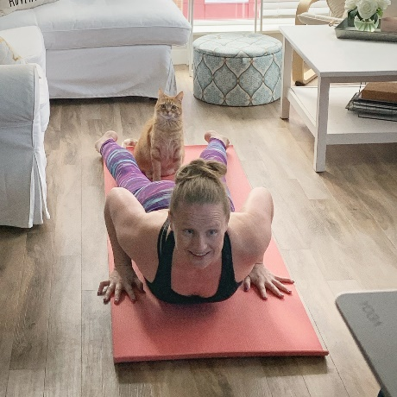
This is a full body flow with standing and seated postures. There is a little extra focus on the hamstring muscles, so remember to modify by bringing some bend to your knees.
If you want to keep workout at 25 minutes, skip final rest at end.
Yoga Routine
https://www.youtube.com/watch?v=f3sQOoWx2Q4&feature=youtu.be
Enjoy
Friday: CrossFit
Watch at least the first 2 minutes of this:
10! WOD
https://www.instagram.com/tv/B_qWOcVF0eX/
If needing a fuller example watch rest of video
*Have a timing device
Complete the 10! WOD as fast as possible and track your time.

Google Form (Due by Friday at 9:00 PM) https://docs.google.com/forms/d/e/1FAIpQLSdJMzalcD_YPBTF4nwECo_4fXyklDoZ3eYWXikpMdssN_hHIQ/viewform?usp=sf_link

