Hello students,
I hope you have had a great weekend and are ready for another week of workouts Here are the workouts for Monday and Tuesday. Please submit the google form by Tuesday at 9:00 PM. I have been spending some time out in North Bend taking photos of an elk herd. Here are a few photos I miss you all!
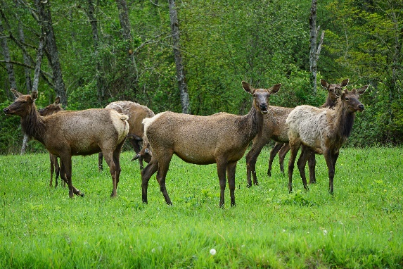
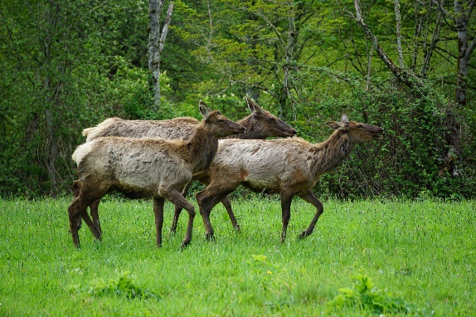

Monday 5-4

PLAN Your Jog: 2.0 Miles

OPTIONS
1- use GMAP Pedometer https://gmap-pedometer.com/
or similar internet mapping service:
2- use a treadmill (if you have access/ must stay inside)

*Have a TIMING device
Complete your 2 - mile jog and keep track of how long it takes using your TMING DEVICE

Tuesday 5-5
Video is 30-minute boxing inspired workout.
-Take note of instruction on how to punch a JAB and CROSS.
- Practice both punches during the workout.
Have fun and enjoy!

Boxing Workout
https://www.youtube.com/watch?v=jCTEVKRTuS8

Google Form: Due by Tuesday at 9:00 PM
https://docs.google.com/forms/d/e/1FAIpQLSfLNZsGUmmuOR_w8J-QvyGoGtJ_8lcJhDeSS-Dx935z_ImlvA/viewform?usp=sf_link

