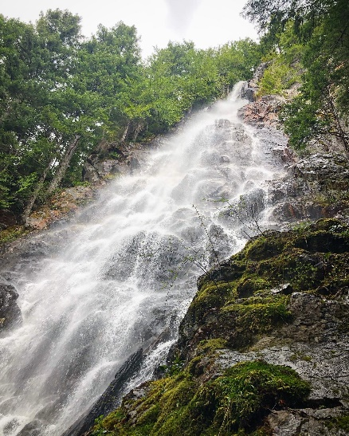
Workouts for 5-18 and 5-19

Hello students,
I hope you all had a great weekend! I included a photo I took from Teneriffe Falls. This is a great day hike at 5.6 miles. Elevation gain is at 1,585 feet. Not super strenuous but gets a little tougher as you start climbing towards the falls. Be careful on the ridgeline as it gets rocky! If you are looking for an outing, check it out!
https://www.wta.org/go-hiking/hikes/teneriffe-falls

Monday 5-18

Introduction:

PLAN Your JOG: 2.0 Miles

OPTIONS
*Use GMAP Pedometer
https://gmap-pedometer.com/
or similar internet mapping service:
*Use a treadmill with incline setting (if you have access/ must stay inside)

*Have a TIMING device
Activity:

Reminder your distance must be at least 2 miles.

Complete your JOG while using your timing device to track how long it takes you to complete.

Tuesday 5-19

Introduction:

1. Make sure you have a place to move around
2. When performing kicks and strikes be careful of hyperextensions. Go light!

Activity:

Follow along and complete this
Krav Maga Cardio Workout

https://www.youtube.com/watch?v=oKi2Vh9rqt0&t=1286s
(Here is the address if the link is not working)
Google Form: Due by Tuesday at 9:00 PM
https://docs.google.com/forms/d/e/1FAIpQLSe2HpFSuTPba7_BIOm2D2a2AuKop44FJQT1ZT6BDPNh-kuqog/viewform?usp=sf_link

